***Hi Dominic,***

***I have tested the provided link eg-*** [*http://www.yukon.cv.ua/*](http://www.yukon.cv.ua/) ***( of your testing website on different tool with various techniques and Unique Testable scenarios.***

***Accessibility Or Usability Testing***

***Each and every tool below mentioned are very unique and descriptively test on various accessibility issues.***

***Using Nibbler Tool*** *– This tool capture whether the given site is how easy access social media , Broken link , images, tags and so on*

*You can rate the website from 1-10*

*PFB The screenshots*

*To see the detail description of the status and the results please follow this link*

[*http://nibbler.silktide.com/en_US/reports/www.yukon.cv.ua*](http://nibbler.silktide.com/en_US/reports/www.yukon.cv.ua)

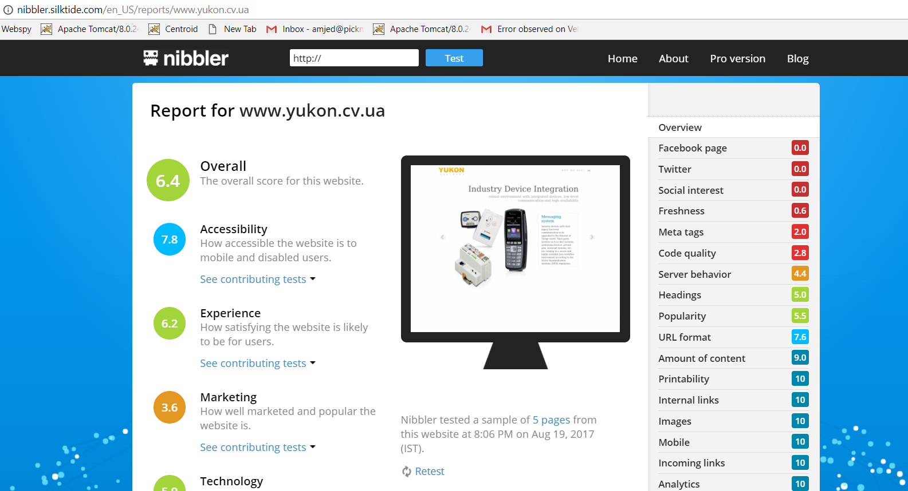

*2)* ***Pages Scoring tool*** *– this tool test the given web link on the following mentioned ( loading speed , style sheet, java script , how quickly site loads )*

*Please Click on the link provided to see the results -* [*http://www.pagescoring.com/website-speed-test/?url=http%3A%2F%2Fwww.yukon.cv.ua%2F*](http://www.pagescoring.com/website-speed-test/?url=http%3A%2F%2Fwww.yukon.cv.ua%2F)

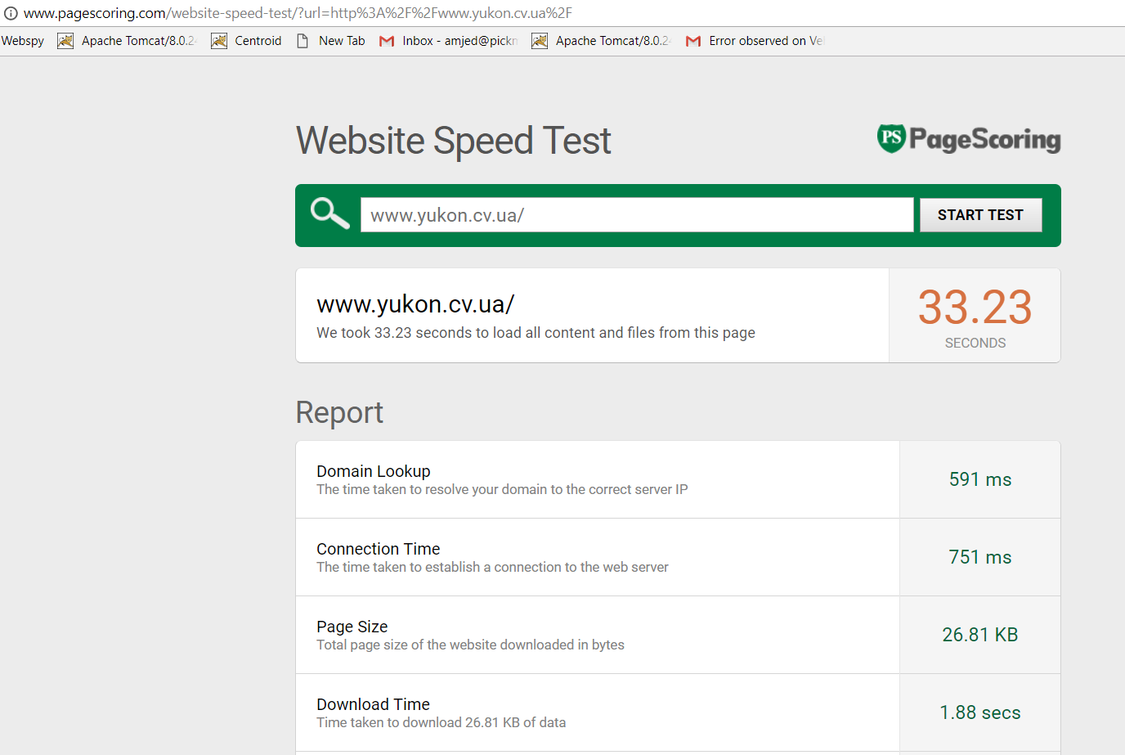

***3)Wave Accessibility Tool –*** *A free tool to check all users have equal access to its functionality regardless whether the user is disable , blind , or even deaf.*

*Please Click on the Given Link to see the exact results to check whether the web link you provided has wave accessibility* [*http://wave.webaim.org/report#/http://www.yukon.cv.ua/en*](http://wave.webaim.org/report#/http://www.yukon.cv.ua/en)

*4)****W3C Standard Tool*** *– this is another powerful tool which check the given site on different and also in a unique style . this mostly checks on plug in, web address*

*Please follow the link to see the results*

[*https://validator.w3.org/check?uri=http%3A%2F%2Fwww.yukon.cv.ua%2F&charset=%28detect+automatically%29&doctype=Inline&group=0*](https://validator.w3.org/check?uri=http%3A%2F%2Fwww.yukon.cv.ua%2F&charset=%28detect+automatically%29&doctype=Inline&group=0)

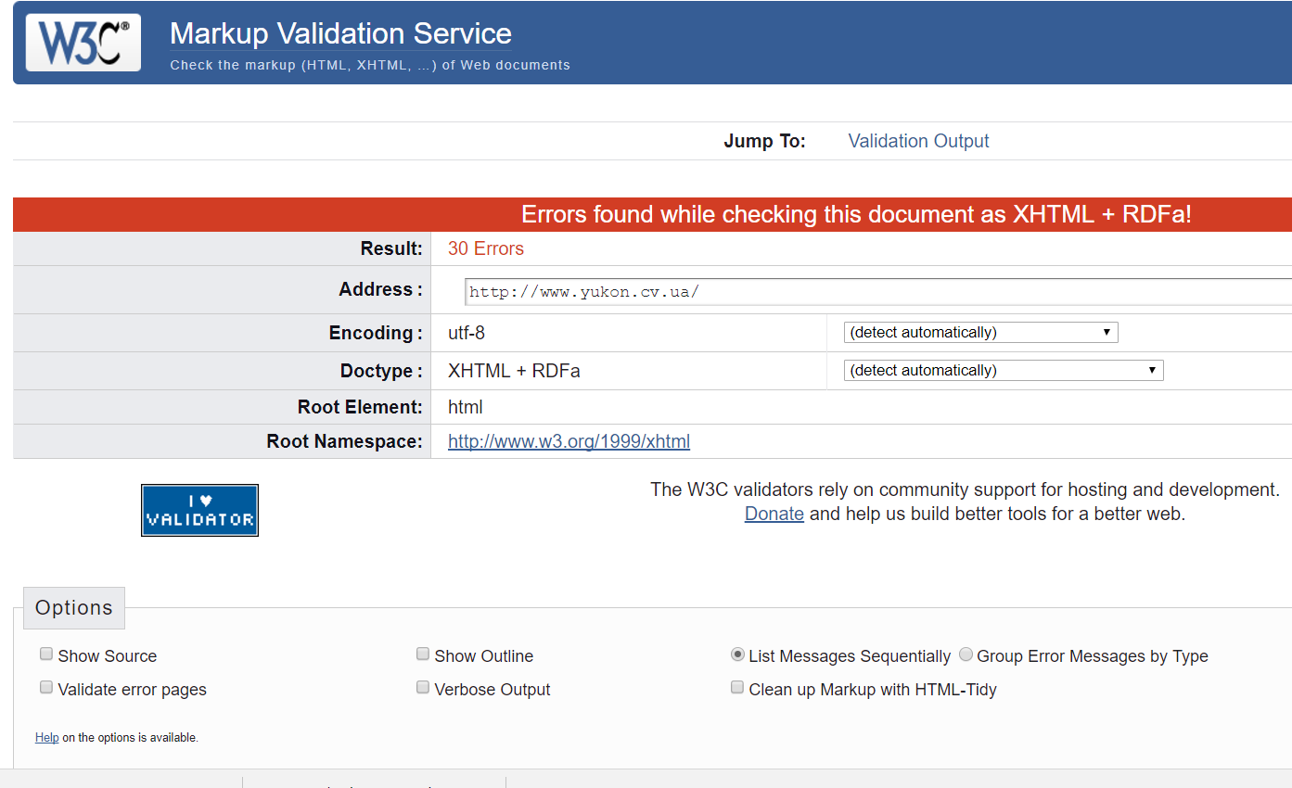

***5)Pingdom Tool*** *– load speed , website faster , automatically trace the performance history, test the website from around the worlds from different city Eg- Boston , Sheffield , site location*

***6)Sort Site Tool****- schedule a test on monthly basis when u fix recent change.*